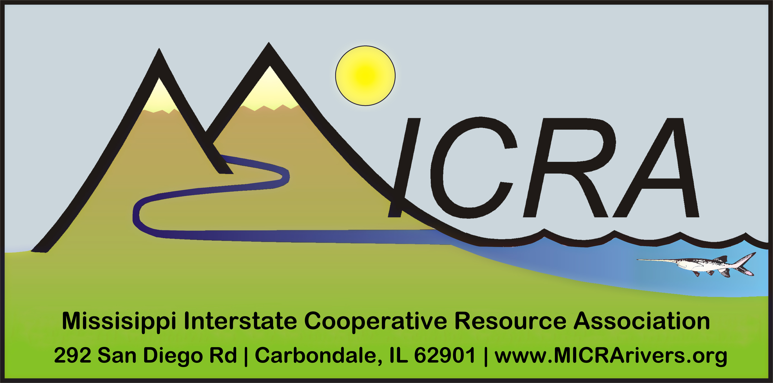

Mississippi Interstate Cooperative Resource Association
RIVER CHAMPION
Nomination Form

The Mississippi Interstate Cooperative Resource Association RIVER CHAMPION AWARD is presented to a Delegate or Committee member who makes an exemplary and/or outstanding long-term contribution to the Mississippi River basin.

_______________________________
Nominee’s Name

Narrative justification (please limit to 2 pages):

I would like my nominee to receive the MICRA RIVER CHAMPION AWARD because...

Signature Date

Please return all nominations to MICRA Executive Board at MICRA@micrarivers.org.

